Analyzing Engineers Writing for Non-engineers

Abstract— Engineers spend a considerable amount of time in communicating with technical and non-technical audiences when on work. Due to the high demands of good technical writing skills, most engineering faculties and engineering educators take special initiatives for fostering such attributes but writing skills for non-technical people is often overlooked. A large number of students stumble into writing with an inadequate sense of the significance of their audience — a problem that needs attention. This introductory study analyzes the engineering students’ writing when addressing non-technical people. We conducted short writing exercises in a third-year engineering course aiming at pitching an idea to non-technical audiences with a view to assessing their ability to adapt their writing according to the audiences. These writings are analyzed using the freely available text analyzing tools. The analysis revealed that students’ writings are complex and tend to address the more qualified people than general audiences. Furthermore, their writings are usually dominated by an analytical tone. The preliminary findings provide ample encouragement to further explore this topic and provide a basis for related practitioners to address this issue and develop strategies to overcome this issue.
Keywords— communication skills, writing analysis, engineering education, writing tone, and teaching/learning strategies.

Introduction
The demand of engineers is continuously growing since the middle of the second century due to rapid developments in science and technology. Writing is an essential soft skill for every aspiring engineer as most of the companies are owned by rich investors who find it hard to communicate technical information in a way that is easily understood by their audiences. This is as important as developing a product and hold value to both organizations and engineers. Therefore, engineers need to possess good communication skills which allows them to transmit information effectively and adds tremendous value to their career. The impressive work produced by engineers is useless unless it is communicated to others in a way that they understand. The reason behind some of the most devastating engineering failures such as the Space Shuttle Challenger disaster (1986) and the loss of the NASA Mars Climate Orbiter (1999), is said to be poor communication.
Communication skills are essential attributes for engineering graduates [1] and this is one of the key outcomes required by an undergraduate engineering programme set by ABET Engineering Criteria 2000 [2] and Washington Accord accreditation standards for Engineers [3]. These accreditations demand that engineering programs must assess students’ technical skills but also professional skills such as effective oral and written communication.
Engineers usually work on large and complex projects which require integration of many groups spread across the component of design as well as the customers and suppliers. Each group comprises engineers with diverse skills carrying out different activities. A research conducted on a groups of engineering graduates of a university providing exhaustive information Australian engineering graduates revealed that about sixty percent of the time at work is spent on communications with other people either through written documents, face to face or over mobile [4]. More precisely, engineers across all disciplines, spend more than 25% of their time in writing documents. Engineers in manufacturing industry of Australian have been found to consume more than 70% of their time on documentation-related tasks [5]. There are many research studies that have identical findings with the total time spent on communication activities ranging from 45% to 75% [6, 7].
Engineers do a lot more writing than what is assumed by the rest of the world. Efforts of an engineer are not complete until the documentation outweighs the final product. Good writing skills bring a lot of benefits to engineers. It improves their prospects of landing a job as better writing skills help in creating a convincing cover letter. The style of writing is one of the main factors affecting the decision of hiring experts [1]. Good writing skills also allow them to promote themselves through presenting their work and achievements to the people all over the world through blogging targeting a large number of audiences that requires communicating in a fashion that is not difficult to comprehend. It makes it easier to communicate ideas and business case with the management and writing the contents in a compelling fashion convinces them and consequently, secure the job. It also helps engineer creating various documents at the workplace which include system requirements, project specifications, technical documentation, warranty restrictions, manuals, and other documentation intended for third-party users. Writing skills also help in communicating with different divisions in the company such as sales, marketing, and other divisions that are not populated by engineering or technical staff. Most of the internal communication is carried out through emails and writing proficiency helps produce lucid emails that makes the job of colleagues easier. Deficiency in written communication skills at the workplace may also have detrimental effects on the levels of stress, deadlines, and well-being, which may result in failure to interpret others work that disastrously affect the ability to solve the problem resulting in inefficiency at work [8].
Engineers often find it hard to manifest themselves succinctly and logically through English text as they deal with mathematical derivations, equations, and programming most of the time. As a result, students get proficiency in writing mathematical equations and expression where the logic is embedded in the language itself but in real-world it has to be elucidated using the words. Writing concisely and logically about the real-world concepts in English is a different art altogether which is hard to master and engineers are no better than the majority of other people [9]. They feel confronted when it comes to the written text and often find themselves distressed when they present the rational arguments to the decision-makers who are often good at it [10]. Many engineers need to master the art of reasoning in a concise and logical way using the language their audience can understand. Furthermore, engineers produce many kinds of writing during their academic as well as professional writing which includes: notes during class sessions, lab reports, written assignments, term papers, e-mails, presentations, memos, proposals, and messages for which students have specific goals and audience for writing [11].
Therefore, academician should help students to learn the specialized register of the engineering profession which will help them to become successful professional. This also increases access to the information and also the ability to participate in varying communities. This is an important skill that needs attention for smoothing the critical transition phase of students from undergraduate education to either the graduate school or workforce. Undergraduate level engineering courses do not really target to develop this capacity in the students.
In addition, engineers need to use various methods to communicate to the rest of the world, such as emails, blogs, commercials, surveys, budget requests, plans, manuals, FAQs, etc. In order to do it effectively, they should be able to convince the customers otherwise they obfuscate the customers and end-users alike. The inability to write for a non-technical audience can dramatically limit the audience. The whole idea is to make everything intelligible for your client. Therefore, when writing, it is important to keep audiences in mind as they are persons who actually be reading your document, or receiving your emails. Engineers usually make the mistake of ignoring the audience. They have to write different documents which are read by the different audiences. Therefore, it is essential to keep audience top of mind as it will change the way of writing the document. A good document is the result of a complex process that factors in readers and their knowledge. In industry, engineers are required to write for a large, diverse audience all with different informational needs and expectations for a report. Sometimes the complexity of the idea could not be comprehended by non-technical personnel if written in a way that is not easy to understand. They are likely to be much less coversant with the technical details and they may act on, or be affected by, the report. The student’s ability to explain the concepts in an easily understandable language is also an indication of the fact that he has a good grasp of the subject. If a student is unable to explain a complex technical concept in non-technical terms, his understanding of the technical concepts may be questioned. Also, the business cases are presented to the people who do not have much technical background and it is important to communicate the benefits of the proposed project or idea to the management in an effective way which is easy to understand.
This small-scale study reported here contributes to our engineering communication awareness by providing information about engineering students’ ability to write while keeping in view the audiences. It was motivated by the research questions: Do undergraduate students have the ability to write for non-technical audiences? In other words, can they adapt the tone of their writing according to the audiences?

Theoretical Framework
There is a trend of incorporating more and more writing exercises to support a broad range of learning outcomes. These exercises are used to reach a deeper level of understanding, enhance students’ abilities of critical thinking, identify learning bottlenecks and misconceptions, and assess student learning in ways that cannot be done with simple calculation-based questions [12]. These in class writing exercises are aligned with the broader Writing Across the Curriculum (WAC) movements [13] according to which writing is the responsibility of the entire academic community. Also, writing instruction must be continued throughout undergraduate education as it encourages learning. Writing assignments are designed to support the goals of Writing in the Disciplines (WID) as it is aimed to gain familiarity with genres and it is used by a large number of WAC programs, although not precisely as our writing pieces are very short. The writing assignment is combined with Writing to Engage (WTE) as it allows students to practice critical thinking as well as engages them in critical thinking.

Discourse Theory
The language can be divided into different levels such as Phonology, morphology, semantics, syntax, and discourse [14]. Discourse may be described in a number of ways, such as conversation or document, a series of texts or conversations, a mutual way of speaking or creating texts (code), codes, languages, and a topic's way of speaking. According to Cambridge Delta, any connected piece of speaking or writing is referred to as discourse. Discourse Analysis is the study of how to relate the distinct 'parts' of language that make up the discourse in such a way that the discourse makes sense. Discourse analysis enables us to find out the reasons if discouse does not make sense [14].

Readability and readability Test
Readability is the simplicity with which a reader can comprehend a written text, according to Wikipedia. Learning and enjoyment are enhanced by easy reading, so what we write should be easy to understand. In natural language, the readability of text is dependent on its content and its presentation [15]. Readability tests are formulae used to evaluate the readability of a text. There are many (more than 17) significant measurable style variables used to measure the readability of the text and most commonly involves counting sentences, words, and syllable. These tests are used as an alternative to perform an actual statistical survey of individual readers of the subject text. A list of the readability tests is provided in Table I.
Writing is analyzed using freely available online text content and readability analyser tool called Analyze My Writing. The output of the tools is in the form readability index which, based on the text's complexity, gives an indication of how difficult a text is to read. There are many indexes available for indicating the complexity of the writing which differ in their working and each emphasizes particular facets of text complexity. Some of them accentuate syllable counts while others look only at the length of the words and sentences. But, all are based on the same core idea; readability is a measure of complexity of the text complexity. Plung [16] has advocated the application of the readability formulas for the writings (even technical) if they are intended for the general public. A list of available readability tool is given below:
- writing analysis tools and readability tests
Writing Analysis Tools | Readability Tests
- Analyze My Writing  - Joes web tools  - ReadablePro  - The writer’s diet  - Text Content Analysis Tool  - Hemmingway Editor | The Flesch formulas, The Dale–Chall formula, The Gunning fog formula, Fry readability graph, McLaughlin's SMOG formula, The FORCAST formula, The Golub Syntactic Density Score, The George Klare studies, The John Bormuth formulas, The Lexile framework, ATOS readability formula for books, CohMetrix psycholinguistics measurements

The application of a useful readability test roughly indicates readability of a piece of writing. The score generated by the tests is based on attributes such as sentence length (as an unreliable proxy for syntactic complexity) and statistical average word length (which is used as an unreliable proxy for semantic difficulty) of the work. Some readability formulas refer to a list of words graded for difficulty. Most of the readability formulas measure word length in syllables rather than letters, but SMOG is the only one which takes into count accurate syllable counter.

Tone analysis
The words and writing style use by an author to convey his or her attitude towards a subject are referred to as tone [17]. The tone should not be confused with a voice which is the author’s personality expressed in writing. It is hard for the author to alter his personality but he can adjust his attitude (tone) which can affect the mood of the audiences.
Tone is communicated by diction, point of view, syntax, and formality level. It is how someone express oneself in speech or writing. In case of formal writings, the tone is normally clear, concise, confident, and courteous. The level of writing must be sophisticated, but not pretentious [17]. The tone of writer is very important when conveying a specific message as it affects the reader in a particular way and also affect how the reader perceives the message being communicated. Some of the tones considered in this paper include: analytical, tentative, confident, sadness, joy or happiness, anger, and fear:

Writing Activities
This instruction methodology, in-class simple writing exercises, was embedded in Digital System Design I course taught during semester one of the third year of computer systems engineering program. This methodology had been perceived well by the previous year students [12]. This course emphasizes on digital systems implementation technologies with focus on hardware description languages and design abstraction levels; RTL design; datapath and control units; structural, architectural and behavioral modelling; functional and timing simulations; implementation design flow for Field Programmable Gate Arrays (FPGA) and case studies.
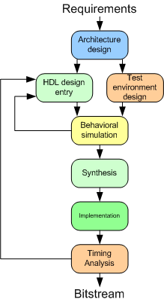
Figure 1: FPGA design flow
Design Flow is a term used to describe the various design phases of an Integrated Circuit (IC) design. The design is usually based on the specification, assuming that they are provided, the most general approach adopted is shown in Figure 1. The informal specification of a digital system are provided by some tender documents which are usually given in a human-readable text or presentation format. These informal specifications are produced by an engineer working in a professional environment. Unfortunately, in the academic environment, students are often provided with the informal specification of a digital system and they never get a chance to go through the two important steps of idea creation and communicating its effectiveness and finally writing down the informal specification of the system. The FPGA design normally starts with the architecture design and steps of problem identification, devising a solution and writing specification are missing. It means they seldom get a chance of going through these important steps of identifying the existing problem to be solved and they only work with the provided specification. The writing exercises are designed to fill the gap identified. Furthermore, the idea for a project comes from inspiration, research, observation, and somebody’s comment. Therefore, this activity can help students in developing aforementioned attributes [12].
There were a total of four short writing exercises and only related one is described next. The students were asked to identify an existing problem faced by the community regardless the scale and propose a real-world digital system which could solve that particular problem. The students were also asked to provide a brief description of the problem as. These artefacts were peer reviewed and submitted again after incorporating the feedback provided.
This activity was mainly a practice of pitching an idea for students by answering following simple questions:
- What is it (idea)?
- What might the product/service do?
- What problem might it solve?
- Who will use it?
- What is valuable to the user?
These pieces of writings can be termed as creative writings as they require saying things in words that engender illusions or that sets up a mood or other covet affects. The students were asked to finish the activity within the stipulated lecture time. In order to ensure equitable access to writing activities and valuing students’ time and adherence to other rendezvous, students were permitted to accomplish the activities outside the lecture time and outside the classroom. It was not compulsory for students to complete the activities for passing the course but it did bear few marks as a reward so that student could be motivated to produce a qualitative and meaning writing. The writings were submitted electronically by the submitted which were graded and feedback was provided to students. The feedback was provided using corrective marks and marginal notes. Former denoted simple phrase or word level errors and latter accentuated the peculiar issues in the writing.

Methodology

Background
The object of this study is to gain an insight of engineering’s writing style and their ability to adapt the level and tone of the writing according to the audience. An rudimentary assumption that has informed our thinking about engineering profession is that writing is an indispensable part throughout the career of an engineer. This inquiry examined a third-year engineering course consisting of computer systems engineering students for two consecutive years with a view to gauge the students’ ability to write for different audiences as well as fill in the gap in the understanding of the Digital System Design course. It is a 15-point medium/advanced level course intended at third-year students of a 4-years undergraduate program offered at the department of Electrical, Computer, and Software Engineering (ECSE). It is founded on the skills and knowledge gained in a prerequisite of this course, Fundamentals of Computer Engineering, taught in the second-year. The objective of this course is to familiarize the students the theoretical expertise and hands-on practice in the design of small to medium size modern digital systems using FPGAs.

Sample
The main data of this study consisted of a total of ~ 79 short pieces of freewriting samples composed by participants in response to the aforementioned activity. The participants were undergraduate students from a large metropolitan university in Auckland took part in this study (8 females; 71 males; average age 21 years). All participating students were registered in Digital System Design I course and obtained no course credit for participating in the experiment. The length of these writing samples ranged between 130 and 350 words.

Evaluation
Professional and technical writings appearing in scholarly articles mostly have a readability score above twelve. Accordingly, texts targeting a wide adult audience should have a score between 8 and 12. Advertising material score ranges from a 5th to 8th grade level subject to the market. Writing is analyzed using a freely available online text content and readability analyser tool called Analyze My Writing [18]. The output of the tools is readability index as explained earlier. The tone of the writings was analysed by using freely available tool called Tone Analyzer which is capable of analysing 7 different tone as mentioned earlier [19].

Measure
This intervention study was approved by the Human Participants Ethics Committee at The University of Auckland (Reference No.: 018848). The lecturers who are also the principal investigators of this study briefed the students about the writing exercises and responded to the concerns raised by the students during a lecture before the launch of acitvities.

Results and Discussion
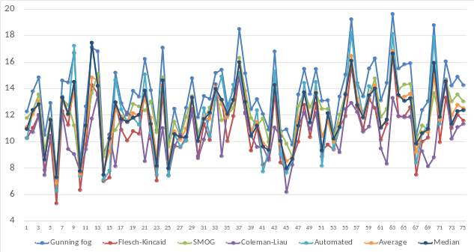
Figure 2: Individual reading levels
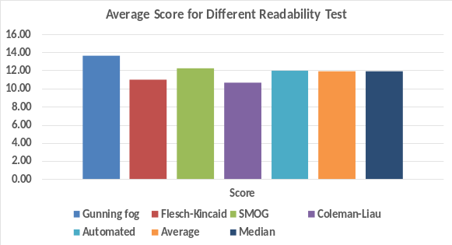
Figure 4: Average reading level
We analyzed all the writings using freely available tool, Analyze my Writing. The score of readability test indicates the grade level required to understand a section of a written work. The grade level of writing needs should accurately reflect the grade level of targeted reader. The score for 5 most widely used readability test is shown for individual writings in Figure 2. The score for five readability tests are: Gunning Fog (Max.=19.63, Min.=7.29, Mean=13.50, Std. Dev.=2.49) Flesch-Kincaid (Max.=16.52, Min.=5.33, Mean=10.90, Std. Dev.=2.31), SMOG (Max.=16.65, Min.=7.49, Mean=12.30, Std. Dev.=1.78), Coleman-Liau (Max.=14.77, Min=6.18, Mean=10.72, Std. Dev.=1.82), and Automated (Max.=18.60, Min.=6.26, Mean=13.50, Std. Dev.=2.79).
The maximum and minimum scores for all five readability test are provided in Figure 3. These score indicate that some of the students are writing at a much higher level than the other. For example, considering the Gunning fog test, the writings span between 7th grader to a person with nineteen years of formal education. The readability score reflects a grade level above or below the grade level of the intended audience, and text requires to be re-written to match intended target.
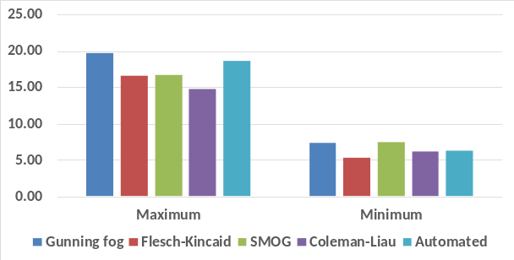
Figure 3: Maximum and minimum levels reading levels
The average for each test and overall average of for all writings are given in Figure 3. The results indicate that on average, students writing target the audience between grade 11 and 14. American adult reads at a 7th to 9th - grade level. In order to obtain the maximum number readers, it is important to keep content within that range. These finding are shared with the students who can take measure to reduce/increasse the complexity of the writing and make it more engaging for the readers. We intend to include a follow up writing in future so that students could see the analysis of their writing by using the tool and resubmit their writing after bringing down or raising the complexity to the required level.
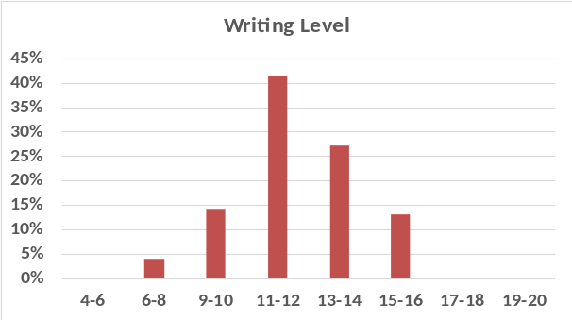
Figure 5: Readability levels of the writings
Around 14% students’ writing were in suitable range for the audiences and 4% writing were too easy. Around 82% of the students’ writing were not suitable for targeted audiences. This is in accordance with Winsor finding that engineering students believe that they are presenting data or giving a detailed account of reality. They never think that they are propounding for an interpretation or persuading an audience through their writing. This can be improved by providing useful feedback otherwise they will have to learn on job by interacting with real audiences. In this way, the students are more conscious about their audience and based on the feedback provided by them, tune the writing to suit their needs. This problem can be fixed during their stay at university so that they are productive when they start their professional career. It will also save the precious resources of the organization spent on training them.

We analyzed the tone of all 79 writings and result are shown in Figure 6. Majority of the writings have analytical tone which was expected as these writings contain the reasons or logic/ justifications to support the idea presented. This also indicates that students analyzed an issue, presented the pros, and compared two scenarios (situation before and after suggested solution) and indicated why presented idea is better etc. This is required from the engineering students that they discard the colloquial write and embrace a more professional, analytical tone. It is preferred that they use precise language, sound confident, avoid unfamiliar language, prioritizing clarity, and get rid of filler words [20].
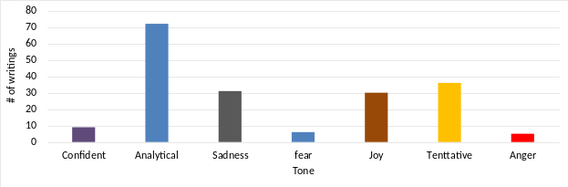
Figure 6: Number of tones in writing
Around ~36 writing pieces had a tentative tone that can be attributed to students’ cautious approach when making their claims as these claims are not proven or established beyond doubt or debate. There were 8 writings that had confident tone and the majority of these writing came from high-performance students. This raises a research question if there is any correlation between the performance of students and the tone of their writing which need further exploration. Also, being too much confident about the idea may result in over claim or exaggeration. The recommended is to avoid boasting about inventive imagination and calibrate the communication by striking a balance between expressing extreme confidence in idea and humility in creative genius.
Other dominant tones are sadness and joy which can be due to the type of problem being addressed. The ideas focused on minimizing human miseries had a sad tone and, on the other hand, ideas improving quality of life or adding luxury had joyous tone. Since these are creative writings it is bound to say things in words that create illusions or that establish a mood or other desired effects.

It was also revealed that many of the writings had multiple tones as shown in Figure 7. More than 42 writings (around 54.43%) have two tones and 16 (20.25%) writings have three tones. There are 8 (10%) writings each which have single tone and four tones. The students’ can be informed that how by using different words in a specific way to improve the tone of their writing for conveying non-verbal observations about specific subjects [20].
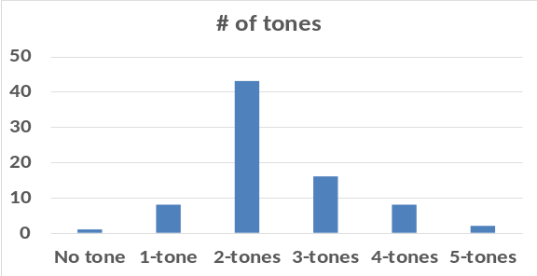
Figure 7: Use of tones in the writings

Study Limitations
This study is a qualitative and exploratory in nature and lays the basis of further initiatives and research. It is conducted for one specific course in an engineering department of a university with less than 150 participants in total. Also, writings are rather short and might have deviation from actual score as some test may require a sizeable specimen of writing so that measured level of difficulty could be considered as valid.

Conclusion
This paper reported undergraduate engineering students’ ability to tune their writing according to the audiences. We found out that a large number of the students tend to write above or below the acceptable level. We also found out that majority of students’ writing have multiple tones largely dominated by the analytical tone. We intend to share our finding with the practitioner in academia who can take necessary initiatives to improve students’ ability to write for the nontechnical audiences. In the future, we intend to explore the reasons which made students write in a way not suited to non-technical audiences. This study found a hint of correlation between students’ academic performance and tone of writing which needs further investigation.

References
- M. J. Riemer, "Communication skills for the 21st century engineer," Global J. of Eng. Educ., vol. 11, pp. 89-100, 2007.
- E. Baum, "Engineering accreditation in the USA – Criteria 2000," in Proc. 2nd Global Congr. on Eng. Educ., 2000, pp.17-20.
- A. A. Anwar, D. J. Richards, and C. Eng, "Comparison of EC and ABET Accreditation Criteria," Journal of Professional Issues in Engineering Education and Practice, vol. 144, p. 06018001, 2018
- Trevelyan, J. (2008). Real engineering is not what you learned at school...… or is it, In Research in Engineering Education Symposium (REES).
- McGregor, H., 2000. Designing a system for the development of communication abilities within an engineering context, Australian J. of Communication, 27(1), p.83.
- Kilduff, M., Funk, J. L., & Mehra, A. (1997). Engineering identity in a Japanese factory. Organization Science, 8(6), 579-592.
- Tenopir, C., & King, D. W. (2004). Communication patterns of engineers. John Wiley & Sons.
- D. B. Lenard and L. Pintarić, "Communication skills as a prerequisite for the 21st century engineer," ELT Vibes: International E-Journal for Research in ELT, vol. 4, p. 11, 2018.
- Becker, H. S., & Carper, J. (1956). The elements of identification with an occupation. American sociological review, 21(3), 341-348.
- Trevelyan, J. (2014). The making of an expert engineer. Crc Press
- Buzzi-Ferraris, Guido, and Flavio Manenti. "BzzMath: Library overview and recent advances in numerical methods." In Computer Aided Chemical Engineering, vol. 30, pp. 1312-1316. Elsevier, 2012.
- Anonymous, 2018
- Ford, Julie Dyke, and Linda Ann Riley. "Integrating communication and engineering education: A look at curricula, courses, and support systems." Journal of Engineering Education 92, no. 4 (2003): 325-328.
- Craig, Robert T. "Metadiscourse, theory, and practice." Research on Language & Social Interaction 32, no. 1-2 (1999): 21-29.
- Dale, Edgar, and Jeanne S. Chall. "The concept of readability." Elementary English 26, no. 1 (1949): 19-26.
- Frase, L. T., A. Rubin, K. Starr, and D. L. Plung. "Readability formulas: Used or abused?[Electronic version]." IEEE Transactions on Professional Communication, PC24 1 (1981): 48-54.
- Beer, David F., and David A. McMurrey. A Guide to Writing as an Engineer. John Wiley & Sons, 2019.
- Analyze My Writing, http://www.analyzemywriting.com/about_us.html; last accessed on 3rd July 2020.
- IBM Watson Developer Cloud, Tone Analyzer, https://tone-analyzer-demo.ng.bluemix.net/, last accessed on 3rd July 2020.
- Laplante, Phillip A. Technical Writing: A Practical Guide for Engineers, Scientists, and Nontechnical Professionals. CRC Press, 2018.

